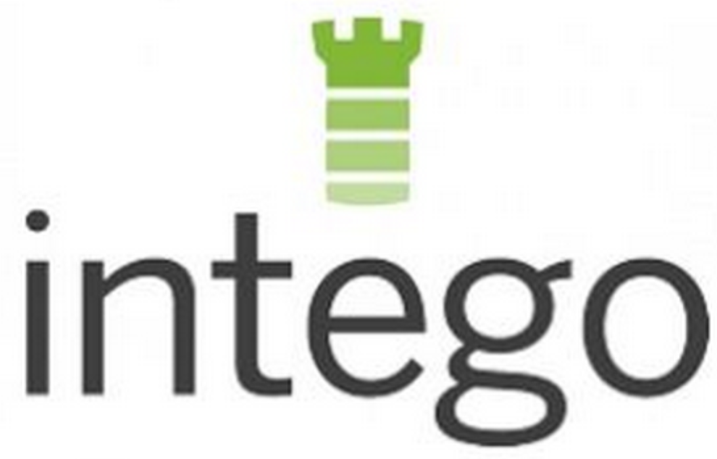

September 10, 2014 08:00 ET

Intego Launches Flextivity™, the First Integrated Security and Activity Monitoring Solution for Mac
New Cloud-Based Solution Helps Small and Medium Sized Business Owners Protect Their Network While Boosting Office Productivity

SEATTLE, WA--(Marketwired - Sep 10, 2014) - Intego, the leading provider of security solutions for the Mac, today announced the launch of Flextivity, the market's first integrated cloud-based security and activity monitoring solution designed with the Mac-based small and medium sized business (SMB) owner in mind. According to research firm IDC, the SMB security market is expected to grow to $5.6 billion in 2015 while some estimates claim that SMBs lose hundreds of billion every year due to lost productivity. With this in mind, Intego has created the first tightly coupled security and activity monitoring solution that offers both flexibility and control to SMB owners.

"As most security experts will attest, employees often represent the weakest link to a company's overall security posture. Whether it's inadvertently executing a piece of malware over email or visiting a hijacked domain, the integrity of most computer networks are most often compromised by employee behavior," said Jeff Erwin, President & CEO of Intego. "This is especially true for small businesses who often don't have a dedicated IT expert on staff. With Flextivity, these businesses can at once secure their entire network while providing top-level activity monitoring that provides an additional layer of behavior-based security enforcement."

As a cloud-based application, Flextivity is easy to set up and simple to administer. With just a few clicks, a business owner can quickly install all of the Macs on their network, ensuring that all of registered computers are fully secured from the latest Mac & Windows Internet threats. There are three plans within Flextivity; Secure, which provides antivirus and firewall protection, Monitor, which provides detailed activity reporting, enabling employers and employees to bring greater transparency to their daily work stream, and Complete which is full integrated with both Secure and Monitor.

Flextivity can be purchased either as a fully integrated solution or as standalone products. Monthly pricing starts at as little as $3.50 per computer for Secure, $8.50 per computer for Monitor and $12 per computer for Complete with discounts for volume purchase, and unlike other solutions, there is no long-term contract or annual commitment.
Some of the key features of the Flextivity solution include:
- Control access to applications: Administrators can configure exactly which applications employees can access as well as when they can access them;
- Customize limits on Internet access: Granular controls allow business owners to set common sense time and location-based limits on Internet access to increase productivity;
- Event triggered screenshots: Administrators can automatically capture screenshots from an employee's workstation via pre-configured or custom keywords, helping protect a company from potential liability concerns; and
- Web content filtering: Managers can set boundaries for Internet use at work, which can be defined by categories, content types (i.e., audio/video), as well as location aware policies.
About Flextivity
Flextivity, developed by Intego, is the only all-in-one security and activity monitoring solution designed specifically for the Mac-based small and medium size business owner. Built and delivered in the cloud, Flextivity empowers small business owners to implement flexible security and activity monitoring policies that deliver a more productive and accountable workforce. More than a million Mac users around the world trust Intego to keep their Macs free of viruses and malware. Founded in 1996, Intego is privately held and based in Seattle, Washington and Paris, France. Learn more about Flextivity at www.flextivity.com or follow us on Twitter: @flextivity.

About Intego
Intego: The Experts in Mac Security and Performance
Intego offers an award-winning line of products providing Mac security and enhancing Mac performance. Intego has been designing software to protect and optimize Apple products for 17 years. No other company has been focused on Mac security and performance as long as Intego -- as evidenced by the dozens of awards its products have received. Intego creates products for a full range of Mac and iOS devices, such as iPhones and iPads. Its depth of experience allows the company to create software that not only works well, but also is elegant and intuitive. Much like a Mac. For more information on Intego, visitwww.intego.com.

# # #

