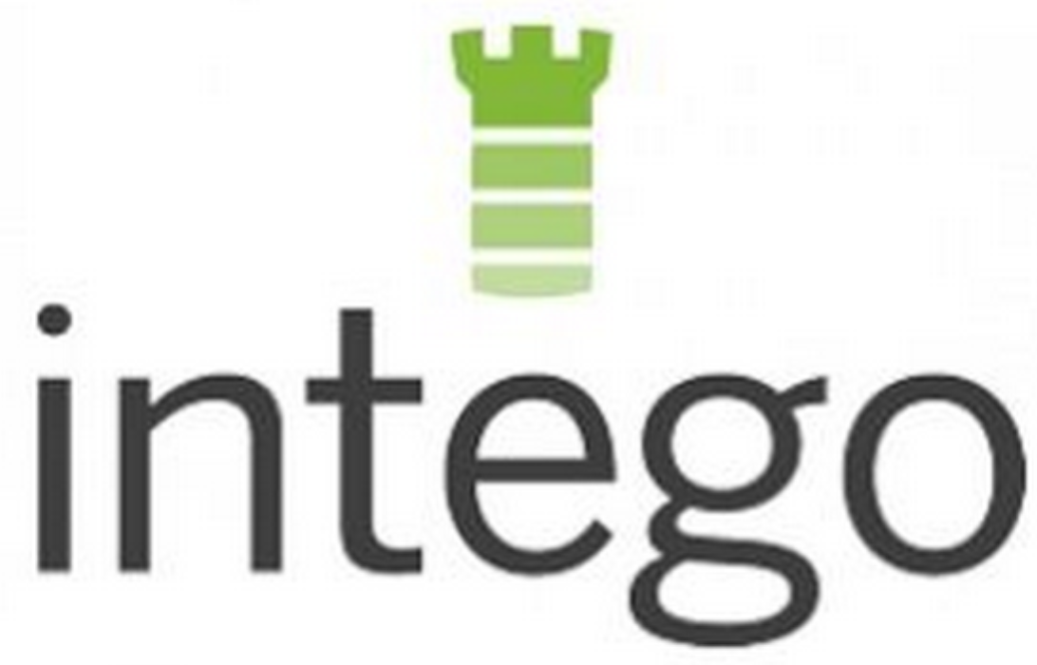

 | FOR MORE INFORMATION:  Beth Llewelyn  Zebra Partners  intego@zebrapartners.net  +1 206-406-5027 | FOR MORE INFORMATION:  Marco Fiori  Bamboo PR  marco@bamboopr.co.uk  +44 207 702 6061

Intego Updates Award-Winning Virus and Malware Protection to iOS Devices with VirusBarrier for iOS 8

November 18, 2014 - Seattle, WA – Intego, the leading provider of security and utility programs built exclusively for Mac users, today introduced its newly updated App Store application for stopping viruses and malware on iOS devices, VirusBarrier for iOS 8.

Based on Intego’s industry leading malware detection rate, VirusBarrier for iOS 8 stops Mac, Windows and Unix viruses and malware from using iOS devices as a gateway to infecting a computer. It scans external files attached to e-mails as well as files accessed from remote locations (such as Dropbox, Google Drive, OneDrive, WebDAV and FTP shares), repairs infected files, and maintains a log of all scans.

For over 17 years, Intego has made protecting Apple products its mission, which means this application is Apple-native and has been specifically designed for iOS devices.
Available for just $0.99, VirusBarrier for iOS 8:

- Features a streamlined UI
- Offers on-demand anti-virus and malware scanning for the iPhone, iPad or iPod Touch
- Includes an integrated file reader to instantly view the document after scanning
- Allows files to be emailed or sent to popular cloud services such as Dropbox and Evernote after scanning
- Scans files for spyware, Trojan horses, adware, hacker tools, dialers, keyloggers and more
- Scans Safari websites for known phishing URLs, web threats, and malware hosting
- Scans ZIP archives

Leveraging Intego's long history and experience with Apple products, VirusBarrier for iOS 8 has been built around user confidence and trust. It safeguards mobile devices, and stops viruses and malware from passing to computers, family, friends or colleagues.
VirusBarrier for iOS 8 is available exclusively on the App Store for $0.99.

System Requirements
- iOS 8.0 or later
- Compatible with iPhone, iPad, and iPod Touch.

About Intego

Intego: The Experts in Mac Security and Performance

Intego offers an award-winning line of products providing Mac security and enhancing Mac performance. Intego has been designing software to protect and optimize Apple products for 17 years. No other company has been focused on Mac security and performance as long as Intego—as evidenced by the dozens of awards its products have received.

Intego creates products for a full range of Mac and iOS devices, such as iPhones and iPads. Its depth of experience allows the company to create software that not only works well, but is elegant and intuitive. Much like a Mac.

For more information on Intego, visit www.intego.com.

# # #

